Digital Lab Notebook
Fantasy Consoles & LLMs

Bryce Anderson
Fall 2024
CIDS Dept.
UW-River Falls
Table of Contents
Page # Topic
Pg. 1-3 ………………………….. Introduction
Pg. 4-5…………………………… Pico 8
Pg. 6……………………………… Cartridge Creation
Pg. 7-8…………………………… Further Development
Pg. 9……………………………… FPS Development
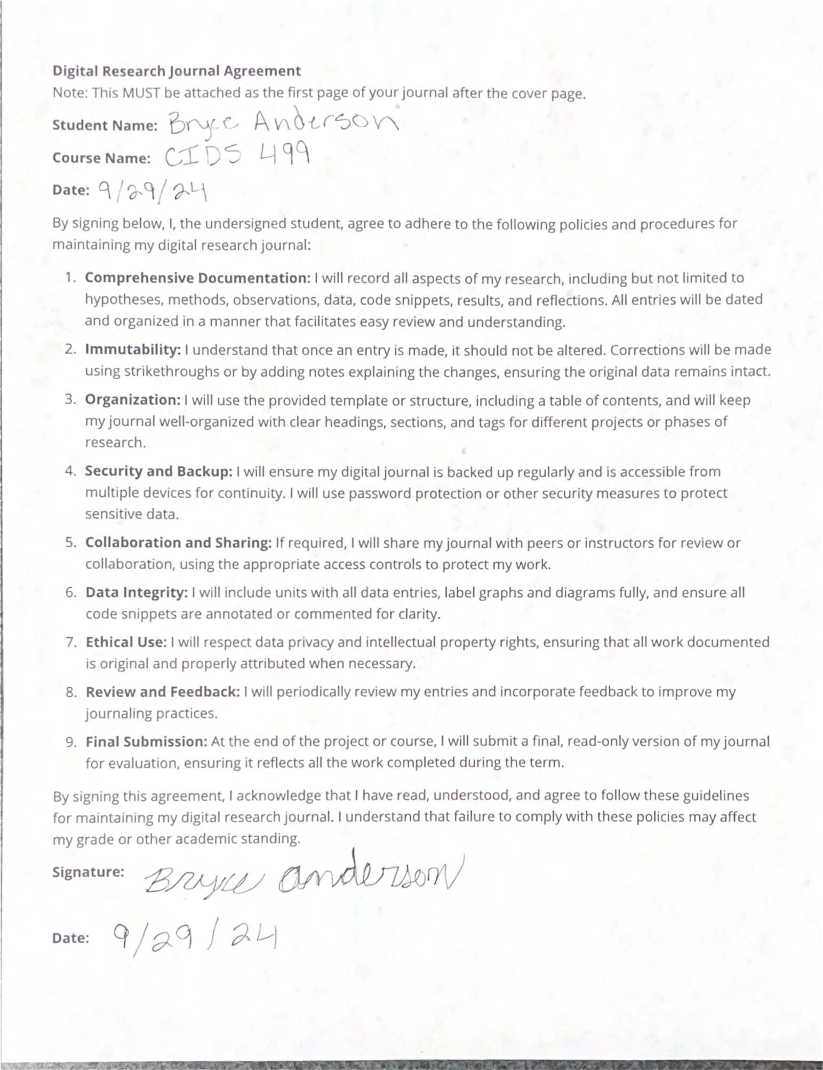

Today I started my research into fantasy consoles and the ability for LLMs to create wild and wacky games for people to play. The idea is to get the crazy ideas of a chat bot, in this case ChatGPT, and then have it create a game for Pico 8 which is the software we will be using to emulate the fantasy console. Pico 8 uses Lua which is a coding language that ChatGPT does know pretty fluently so the thought is that it shouldn’t have to hard of a time creating functioning games just by being given prompts.

To do list:
- Use Pico 8 and get comfortable with the software
- Start a digital research notebook and sign agreement

Tasks Completed:
- Signed digital agreement and reviewed the template for a digital notebook

Tasks Completed:
- Downloaded Pico 8 and started to learn how to use and write code for the software.

From what I can tell it is a super simple interface that allows easy creation of sprites and sounds on top of the code, so it has all the tools you need to code a full retro type of game. I will also say it is different getting used to the interface for the fact that it is more like a directory by using the ESC key to get back to your command prompt, but with time I see no issues getting comfortable with it.

Tasks Completed:
- Get comfortable with Pico 8

I was able to code a simple cartridge that has a sprite you can control with controls to move left and right. From what I can tell it seems like the code is similar to python which I don’t have the most experience with, but Lua seems a bit simpler since it is so restricted with what you can do because you aren’t making high resolution games, and you only have so much memory to allocate on something like this.

Tasks Completed:
- Fully created and update digital research notebook
- Asked ChatGPT to write a game for Pico 8

I asked ChatGPT to write me a puzzle game in Lua for Pico 8 and Image #1 shows the start of the game. The goal is to push the orange blocks to the green squares or the target spots and once all are in the correct spot you will win the level.
Image #1

After playing the game and achieving the win condition there was no indication on if I won the game or not as shown in Image #2. I also was unable to move onto the next level, so this meant something was wrong with the win condition. In order to fix this, we needed to add an extra layer of logic to see if the block occupied the same position as the target spot.
Image #2
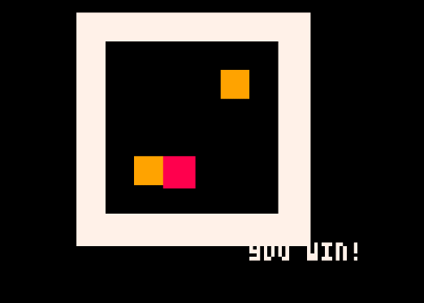
After retrying the code now checking if the block is in the same position as the target spot I still was having no win condition pop up. This was then fixed by adding a game won flag which makes it so after the win condition is met then it will restrict player movement and display the win message as shown in image #3.

Image #3
From what I can tell ChatGPT can pretty easily make simple games written in Lua for Pico 8. The only hiccup is that you need to figure out what isn’t working in the code and tell the LLM, after a few times it seems like it figures out what needs to be changed for it to function properly.
https://chatgpt.com/share/670574ef-2a00-8006-b78d-b618a4c9e992

Tasks Completed:
- Create more cartridges using ChatGPT and Pico 8
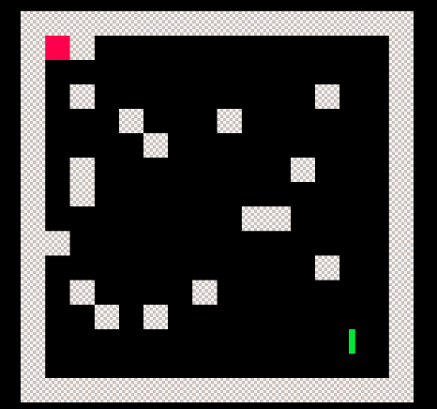
Dungeon Crawler
https://chatgpt.com/share/670eaf41-5e28-8006-b983-3cebb7f3f26a
From what I could tell it seemed like giving ChatGPT a more precise type of game caused some confusion and required more conversation to get the game functioning. I had to correct many issues before I was even able to see what the game looked like.

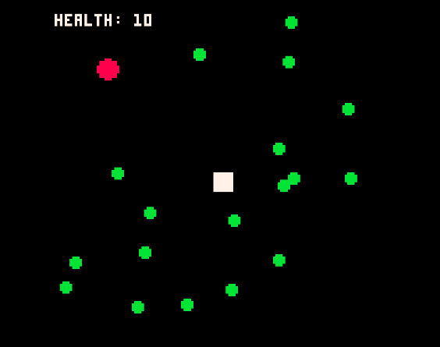
Fantasy
https://chatgpt.com/share/670eb5bc-c5ec-8006-9f6c-7a3edf822549
The fantasy game seemed once again to be easier to get functioning and I assume this is because the more precise prompt you give ChatGPT the harder time it will have creating a fully functioning game in Pico 8(this is not proven it is just a guess/hypothesis).

While doing this I also noticed that ChatGPT seems to think that you have resources for the game already created. I say this because as it gives you the first draft of the code it seems that it gives you a large list of things that you will be able to do in the game, however when you try to run the game you get way less than what was described. This is where you then have to tell ChatGPT what issues you can notice or even just let it know that a certain feature isn’t working, and it then generates the code you need for that feature usually without problems.

Tasks Completed:
- Investigate sprite/music generation
- Try to upscale one the games created previously

I asked ChatGPT if it were possible to have it create sound effects and or sprites for a game in Pico 8. From the response that was given by ChatGPT I feel like it makes sense with the way you create these assets in Pico 8. It said that it can suggest concepts and help guide you through the creation of these assets, but it cannot directly create these assets for Pico 8.
https://chatgpt.com/share/6717db87-1f3c-8006-a083-830af6452e02
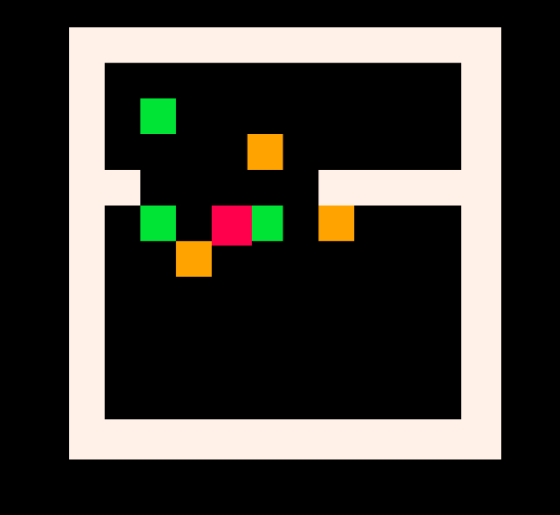
When upscaling the puzzle game I noticed that again the complexity of the game seemed to cause more confusion. With adding another level there were constant issues of blocks not spawning in accessible locations and a variety of other issues. With enough conversation with ChatGPT I was able to get the second level working properly.

https://chatgpt.com/share/6717e6e5-c384-8006-ae56-569893d269ac

Tasks Completed:
- Continue upscaling puzzle game
- Started Development on FPS Doom-like game
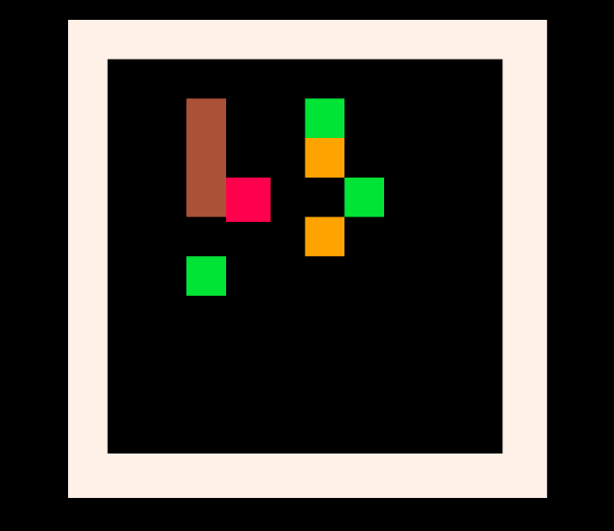
The process for adding a 3rd level to the puzzle game seemed to be just as troubling as adding a second, I was constantly running into issues where the new pitfall mechanic would not work, and players could just push blocks right over the top or I was having issues with blocks spawning in invalid positions on the map. After continuous conversations and pointing out errors I was finally able to get the pitfall working to allow blocks to fall in making them unusable once they have fallen. I also currently have one slight issue where not all the blocks are needed to complete the level as there are more target positions compared to usable blocks on the map.
https://chatgpt.com/share/6732839c-7340-8006-85a9-76ace9c9c3e2

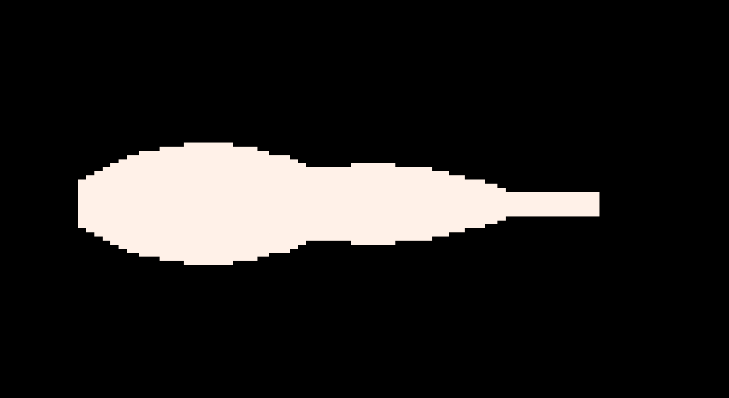
The FPS Doom-like game I feel like is going to take some time to fully finish, but to start I have a very rough raycasting engine that ChatGPT designed to emulate and display a pseudo-3D view. The player is able to move forwards, backwards, and turn in both directions.

https://chatgpt.com/share/673288b6-d2a8-8006-9e69-8441e3de9b78

Tasks Completed:
- Continued Developing the FPS game
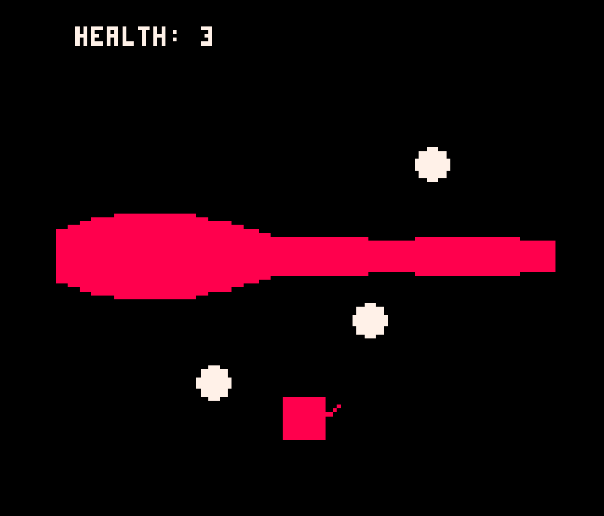
Once I set up the raycasting to emulate a 3D environment that is where I found most of the issues continuing this FPS game. The enemies are just stuck on the screen or as you move around they slowly move out of frame and then you can’t get them to display again. Also, the gun is hard to understand as the graphics are very basic and the effects to shows your shots is very weird currently. I have also had issues with the health bar not displaying correctly or any death screen.
https://chatgpt.com/share/673288b6-d2a8-8006-9e69-8441e3de9b78
